Parth Babbar

Cloud Computing in Banking

Introduction:
Cloud computing has revolutionized several industries, including banking, by providing scalable, adaptable, and cost-effective solutions. The use of cloud computing in the US banking sector is rising, driven by the demand for higher operational efficiency, a better client experience, and strong data management capabilities. This study investigates the acceptance, advantages, problems, statistics, and future prospects for cloud computing in US banking.
Adoption:
Over the last decade, the banking sector in the United States has used cloud computing extensively. Banks are adopting cloud technology to upgrade their IT infrastructure, facilitate digital transformation, and gain a competitive advantage. Cloud computing enables banks to access computer resources on-demand, eliminating the need for huge capital investments in physical gear and software.
- Public Cloud: Banks use public cloud services offered by providers such as Amazon Web Services (AWS), Microsoft Azure, and Google Cloud Platform (GCP). These services provide scalability, cost-efficiency, and a diverse set of tools for various banking activities.
- Private Cloud: Some banks choose private clouds due to increased security and control. Private clouds are often hosted on-premises or in specialized data centres
- Hybrid Cloud: Many banks use a hybrid cloud strategy that combines public and private cloud environments to balance scalability, cost, and security.
Key Features:
- On-Demand Self-Service: Banks may manage computing resources without requiring human participation. For example, developers may use a cloud platform's self-service interface to swiftly deploy new apps, increasing productivity and creativity.
- Broad Network Access: Cloud services may be accessed via the internet from a variety of devices, including mobile phones, tablets, and laptop computers. Bank personnel, for example, may access cloud-based programs and data from any location, allowing them to work remotely and increase productivity.
- Resource Pooling: Cloud providers combine computer resources to serve several clients, allowing for more effective resource allocation. For example, a bank's many divisions can use the same cloud resources, maximizing usage and lowering expenses.
- Rapid Elasticity: Cloud services may be swiftly scaled up or down to meet changing needs. For example, a bank can rapidly raise its cloud resources during peak transaction hours while decreasing them during off-peak times.
- Measured Service: Cloud systems employ metering to automatically regulate and optimize resource utilization, ensuring that banks only pay for what they use. For example, a bank may track its cloud usage and charges in real time, enabling for improved budget management.
- Disaster Recovery and Business Continuity: Cloud providers provide sophisticated disaster recovery solutions, allowing banks to swiftly restore data and keep operations running during outages. For example, a bank's data is backed up and replicated across various data centres to ensure its availability in the event of a crisis.
Benefits:
- Cost-Effectiveness: Cloud computing minimizes the need for significant upfront IT investments, resulting in more predictable expenses. For example, Capital One saved greatly by migrating its programs to AWS, which reduced data centre expenditures.
- Scalability: Cloud systems enable banks to expand resources in response to demand, managing fluctuating workloads effectively. For example, during peak transaction periods such as Black Friday, banks might expand computing resources to handle more traffic while scaling them back down during off-peak periods.
- Agility and Innovation: Cloud computing enables banks to innovate more quickly by offering a flexible environment for building and deploying new applications. For example, JPMorgan Chase employs cloud services to accelerate the launch of new financial products.
- Enhanced Security: Leading cloud providers provide sophisticated security and compliance certifications to assist banks secure sensitive data and satisfy regulatory standards. For example, Google Cloud's GDPR and CCPA compliance guarantees that banks meet severe data protection regulations.
- Data Analytics and AI: Cloud systems provide advanced data analytics and AI capabilities, allowing banks to obtain a better understanding of consumer behaviour and improve operations. For example, Bank of America uses cloud-based AI systems to analyse client data, hence enhancing fraud detection and customer service.
Challenges:
- Security and Compliance: Despite improved security measures, worries regarding data breaches, regulatory compliance, and data privacy remain major issues.
1. Data Breach: Banks continue to be top targets for cyberattacks, with a high risk of data breaches.
2. Regulatory Compliance: Banks must follow different rules, including GDPR, CCPA, and PCI DSS.
- Integration with Legacy Systems: Many banks still use legacy systems that are incompatible with cloud technology, complicating the transformation process.
1. Legacy System Compatibility: Transitioning from legacy systems to cloud platforms may be complicated and time-consuming.
- Vendor Lock-In: Reliance on a single cloud service provider may result in vendor lock-in, which reduces bargaining leverage and flexibility.
1. Vendor Lock-In Risk: Banks may become reliant on a single cloud provider's ecosystem, which can be expensive to alter.
- Data Governance: Maintaining effective data governance and control in a cloud environment is difficult, particularly when dealing with sensitive financial information.
1. Data Control: Banks must keep control over their data while complying with numerous rules.
Solutions:
- Enhanced Security Measures: To secure data, banks should employ multi-layered cloud security measures such as encryption, identity and access control, and continuous monitoring. For example, implementing a zero-trust architecture guarantees that all users and devices get ongoing authentication and authorization.
- Compliance Management: By using compliant cloud providers like as AWS and Azure, regulatory problems are efficiently addressed. For example, they follow GDPR, HIPAA, and PCI DSS laws.
- Hybrid Cloud Approach: A hybrid cloud approach mixes on-premises and cloud resources to simplify migrations and increase flexibility. For example, banks can keep sensitive data on-premises while using public clouds for less important operations.
- Multi-Cloud Strategy: Using various cloud providers helps decrease vendor lock-in while increasing resiliency. For example, a bank may utilize AWS for basic banking apps, Microsoft Azure for customer relationship management (CRM), and Google Cloud for data analytics.
- Data Governance Framework: Creating a solid data governance framework that includes rules, processes, and technologies guarantees safe cloud data management. For example, employing solutions like Informatica or Collibra helps to manage data quality, lineage, and compliance successfully.
Future Outlook:
The future of cloud computing in US banking is bright, with technological improvements and increased adoption among financial organizations. Key trends influencing the future include:
- Increased Adoption of AI and Machine Learning: To improve decision-making and customer experience, banks will increasingly rely on cloud-based AI and machine learning capabilities.
- Expansion of Cloud-Based Services: More banks will use cloud-based core banking systems, payment processing, and fraud detection.
- Sustainability: Cloud providers are investing in green technology and energy-efficient data centres to comply with banks' sustainability objectives.
- Improved Customer Experience: Cloud computing will allow banks to provide more tailored and seamless customer experiences via novel digital channels.
Statistics:
- Adoption Rate: As of 2023, over 91% of banks in the United States have implemented some type of cloud computing, with 67% employing several cloud services.
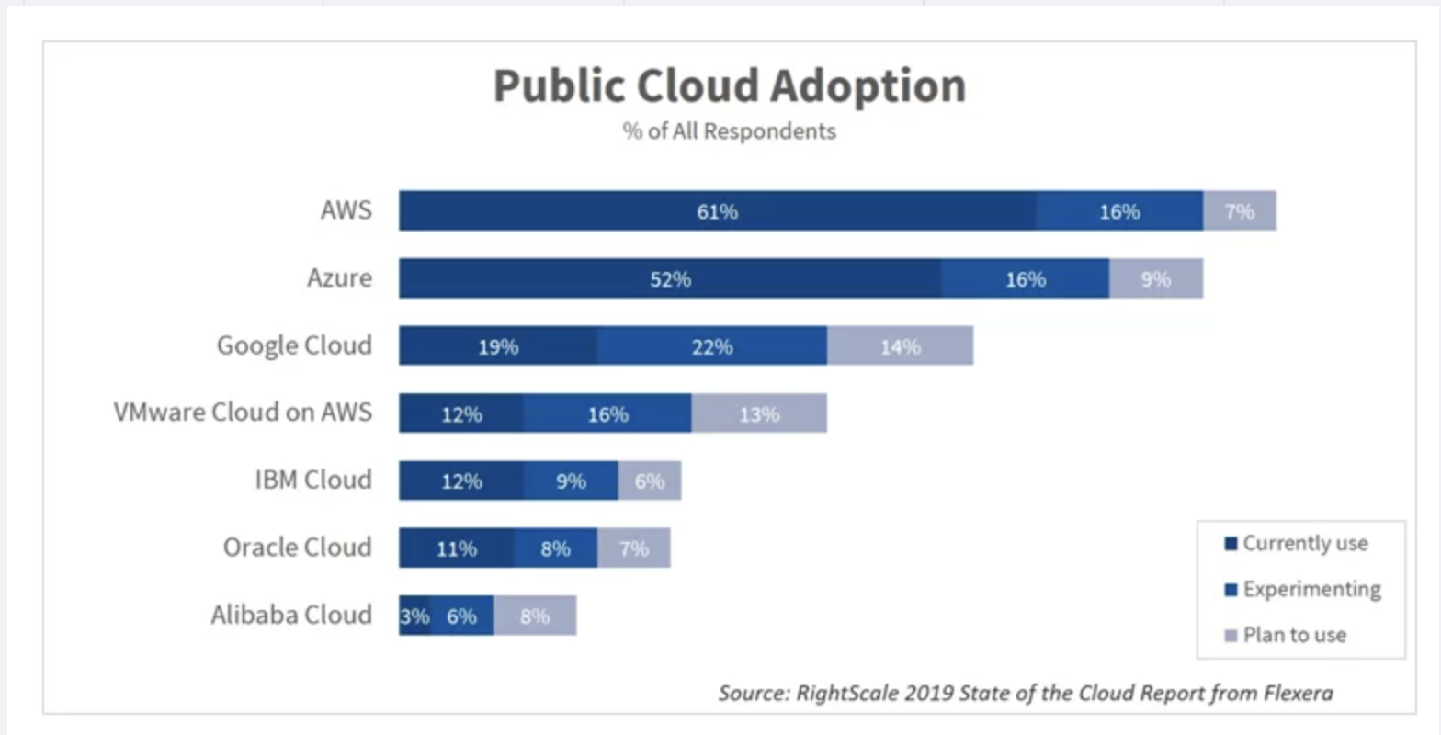
- Market Size: The worldwide cloud computing market for banking is estimated to reach $52 billion by 2026, with North America accounting for the lion's share.
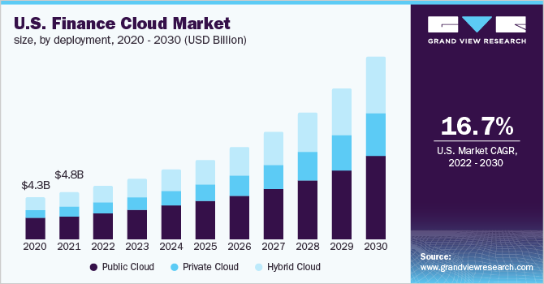
- Cost reduction: Banks that use cloud computing estimate an average IT cost reduction of 15-25%.
- Operating Efficiency: Financial organizations that use cloud solutions see a 20-30% increase in operational efficiency.
Conclusion:
Cloud computing is altering the US banking industry by delivering scalable, cost-effective, and creative solutions. While there are problems like as security, compliance, and interaction with legacy systems, banks may overcome them by implementing best practices and employing sophisticated technology. As cloud computing becomes more widely adopted, it will play an important role in melding the future of banking by increasing efficiency and consumer happiness.

